RE Macro Economics Final Quiz
Objective: My goal with this assignment is to determine which of the eight given metro areas is the best and worst investment choice. To do so, I will run two ECM regression models: one with nominal rent growth and the second adding CPI. I will then use the residuals from my second model (I prefer it because it factors in CPI) to estimate which markets are the best and worst to invest in compared to their historical average.
Model 1: ECM with Nominal Rent Growth
I started by cleaning the given data by separating each metro into its own tab and constructing the CAP(T-4) and Rt/Rt-4 variables. Then I set up the columns to run the regression formula listed below.
CAP_{t} = β + α₁ CAP_{t-4} + α₂T10_{t} + α₃ (R_{t}/R_{t-4})

I started my regression in 1988.1 because the two constructed variables do not begin until that period and I wanted to have continuous data for the regression. My results for model 1 for the eight metros’ are shown below:
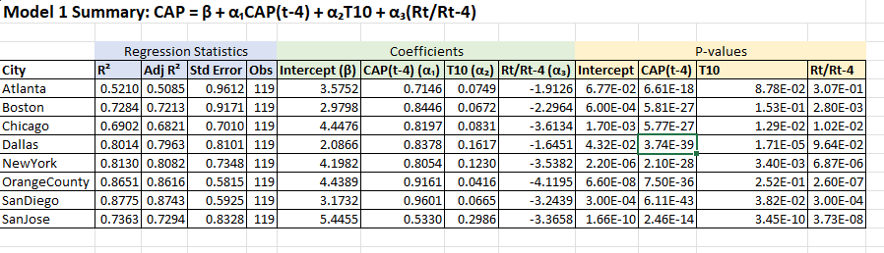
Q1: In the strict GGM formulation, the coefficient of the 10-year would be similar or even identical (but of opposite sign) to that on rent growth. Why do you think that is not true here?
The Gordon growth model starts with the following formula when applied to real estate:
$$Value=\frac{NOI}{CAP RATE}$$
CAP RATE actually consist of two values: the required return R, and the long run expected income growth G. They are in the relationship R-G. Using the data given, I will assume that the discount rate (R) is equal to the 10Y Treasury value (T10) and G is the rent growth ratio which we calculated as (R_{t}/R_{t-4}) in the first regression.
Therefore, in an idealistic GGM model: Cap Rate= T10- Rent Growth
Because of this we would expect coefficients of these variables in the above regression model to be roughly equal and opposite…. A one point increase in R would increase the Cap Rate by the same amount and a one point increase in rent growth would decrease the Cap Rate.
This is not borne out by the results of our model. For all metros but Atlanta both the discount and growth rate are statistically significant but growth has a much larger coefficient (though they are all directionally in line with the idealistic GGM formulation). There are a few reasons this may be the case:
- In the real world there is also a risk premium above the 10Y Treasury that is demanded by investors for risky projects such as real estate. This risk premium is not constant throughout time but is changing based on expectations for the economy. A 1 point move in T10 does not translate into a 1 point move in cap rates because risk premium is also a component of that value.
- Our rent growth indicator is backward looking, because that is the best data we have. But in the GGM and real world rent growth is heavily driven by expected rent growth in the future, and this plays a large role.
- In real world transactions, Cap Rate adjust slower than the GGM idealistic view which would be an immediate adjustment. The ECM does capture this through the lagged dependent variable, but this is another reason the coefficient of the two variables is not the same.
Model 2: ECM with CPI
I started by constructing an additional variable (CPIt/CPI(t-4)) to get the following regression formula.
CAP_{t} = β + α₁ CAP_{t-4} + α₂T10_{t} + α₃ (R_{t}/R_{t-4}) + α₄ (CPI_{t}/CPI_{t-4})
I ran the regression the same way as the first model, starting at period 1988.1 to account for the start of the lagged variables and use continuous data. My results for the eight metro’s using model 2 are shown below:
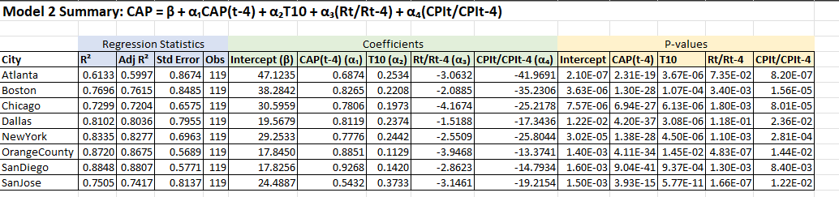

Q2: Why do you think these two coefficients are so different in magnitude (although both are generally significant)?
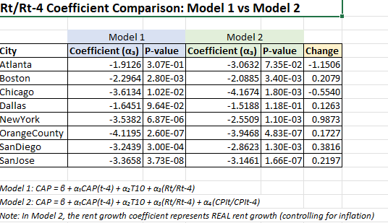
As mentioned in the question, the coefficients between the models vary greatly. One additional observation of note: rent growth in model 1 was not statistically significant in every city, but it was in model 2.
These variations are not surprising. In fact, this flushes out the difference between inflation and real rent growth. Real rent growth is uneven, and even with changes in national inflation local property market dynamics can drive situations of shortages/surpluses that also effect real rent growth. In summary, model 1 does not separate these components, but model 2 separates them by also including a CPI variable.
Q3: Is estimated long run coefficient on 10-year near to 1 as in the GGF?
The ECM only gives us the short run coefficient of T10 for a given quarter. However, cap rates are continuously dynamic, and a shock or change will cause a cap rate to adjust over multiple periods. Therefore, we need to account for this dynamic to find the long run coefficient of T10. I formulated the connection between short term and long term CAP as follows.
CAPt=CAPt-4=CAP*
CAP* = β + α₁CAP* + α₂T10 + α₃(Rt/Rt₋₄) + α₄(CPIt/CPIt₋₄)
Solve/reduce equation for CAP* to get α₂/(1- α₁)

Here are my results for the model 2 data:
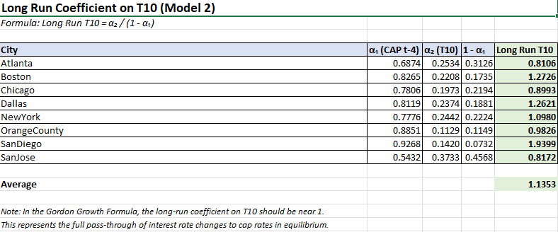
The results show that most cities are close to one which supports the GGF theory. This finding confirms that RE markets do reprice in response to interest rates. One key outlier is San Diego. What is interesting for San Diego is that Cap Rates are extremely persistent in that market (.93) which suggest they are sticky and do not change quickly. However, the high long term T10 value suggest that while they are slow to change quarter to quarter, the cap rate actually changes a lot more than the GGF would suggest. My hypothesis for this is that San Diego real estate is always in demand so owners may be reluctant to reprice quickly but in the long term this just delays and amplifies the adjustment.
Q4: How similar now is the coefficient on the 10-year to the average of the coefficient on rent growth and that on inflation?
Once again, per the GGM we expect Cap Rate= r-g, and that they should be equal in magnitude. I ran an analysis of this by assessing whether α₂= average of α3 (and α4). Here is what I found:
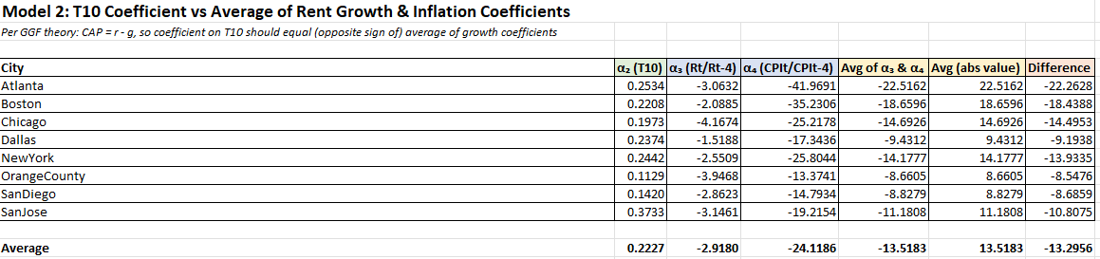

T10 coefficients are not roughly equal to the average of coefficients of rent growth (α3) and inflation (α4). In reality, T10 is much smaller, and the CPI is quite large, which suggest that in the short run cap rates are much more sensitive to changes in inflation than interest rates. This makes sense because interest rate changes are a delayed effect of changes in inflation.
One note: This comparison is difficult to make because the variables are measured on different scales (ratios vs. percentages).
Investment Criteria/Decision:
Q1: Regression residuals (actual – predicted) must sum to zero over the full sample by construction.
With the OLS regression, residuals must be zero over the full term history of the data. So it cannot be overvalued or undervalued for the entire time history. My takeaway here is that this fact gives me context for my recommendations because when considering the last two years of residuals, where they sit is simply how they relate to the historical average for that market.
Q2/3: Examine the residuals over the last 2 years of the sample as an indication of how “current” market pricing compares to the GGM prediction – estimated specifically from that market’s historic data. How do the results of this comparison vary across the other markets in the data set?

Here are my results using my Model 2 data.
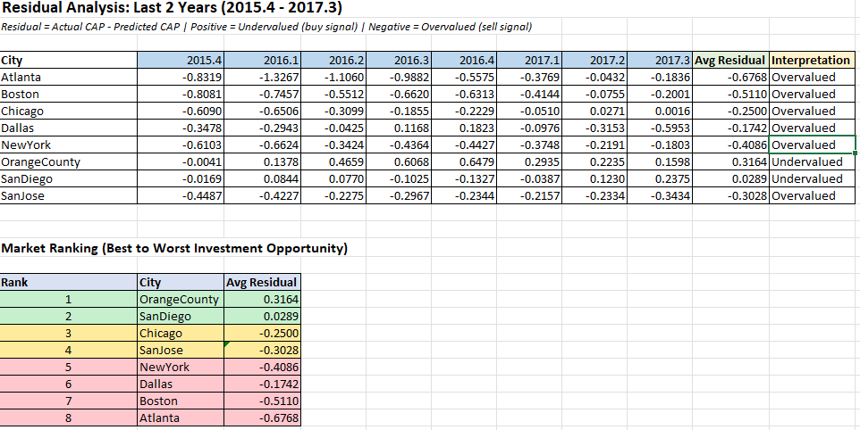
Recommendation: Based on my analysis Orange County is the best market to invest in and Atlanta is the worst location to invest in. More specifically, OC is relatively underpriced relative to it’s historical average and Atlanta is overpriced relative to historical averages. In general, I used the criteria of any residuals above zero as undervalued and any residuals below zero as overvalued.

Overall, most markets have negative residuals. This tells me that the office market (broadly speaking) became more expensive in this two year period. My hypothesis is that this is due to value cap rates compressing during a long period of low interest rates.

